

For Examiner’s Use

Examiner’s Initials

Question | Mark
1
2
3
4
5
6
7
8
9
10
11
12
13
14
TOTAL

Centre number |  |  |  |  |  | Candidate number
Surname | Massingham
Forename(s) | Benjamin
Candidate signature
 | I declare this is my own work.
Programming Language | Python (7517/1D)

A-LEVEL COMPUTER SCIENCE
Paper 1

January 2024 (Mock Examination)
Time allowed: 2 hours 30 minutes

Instructions
- This is the Electronic Answer Document (EAD). Answer all questions by entering your answers into this document on screen. You must save this document at regular intervals.
- Before the examination begins, type the information needed in the boxes at the top of this page.
- Before the examination begins, type the information needed in the boxes in the footers (page 2 onwards) of this EAD.

During the examination
- You may print pages of your EAD. A print monitor will collect and deliver your print-out to you. You must not collect your own print-out.

Exceptions
- If you experience difficulty inserting screen shots into your EAD then you may print these separately and attach them to the back of the EAD with a reference in the correct place in the EAD. Ensure that your Centre Number, Candidate Name and Candidate Number are on each sheet.

At the end of the examination
- Save for the last time and print your EAD on one side only (not
double-sided). A print monitor will collect and deliver your print-out to you. Check that your details are in the footers from page 2 onwards. Write them in if they are not.
- Enter your signature on the front cover.
- Staple or tie all pages together in the top left-hand corner of the EAD.
- Hand in all pages of the EAD to the Invigilator.

Warning
- No extra time is allowed for printing and collating.
- It may not be possible to credit an answer if your:
– details are not printed on every page as instructed above
– screen captures are not legible to the Examiner.
Answer all questions.

You must save this document at regular intervals or you may lose your work.

Section A
 |  |  |  |  |  | Leave blank
Question 01
0 | 1 | . | 1 | Firstly, we need to check and make sure that the list is not full. If it is not full we input the item. Once we have inputted the item into the list we need to make sure we move the front pointer forward one space. As it is a static data structure we need to use pointers so that it can act like a dynamic one.
0 | 1 | . | 2 | Dynamic data structures grow and shrink with the amount of data in them whereas statis data structures are a constant size  Static data structures use pointers to indicate the front and the back of the list whereas dynamic data structures don’t  Static data structures can only hold a set amount of data whereas dynamic data structures can hold as much as they want
0 | 1 | . | 3 | Jib
0 | 1 | . | 4 | Jib
0 | 1 | . | 5 | If the queue empties its data into a stack and then the stack empties its data back into a queue, the data will reverse due to the different ordering mechanisms that both the structures use
 |  |  |  |  |  | 12

 |  |  |  |  |  | Leave blank
Question 02
0 | 2 | . | 1 | Its not pink
0 | 2 | . | 2 | Its not a triangle
0 | 2 | . | 3 | Blue
 |  |  |  |  |  | 3

 |  |  |  |  |  | Leave blank
Question 03
0 | 3 | . | 1 | Each node only has two branches, there are no cycles
0 | 3 | . | 2
  0
  -1
  True
  Current = Tree[Current].Right
  Current = Tree[Current].Left
  False
0 | 3 | . | 3 | ½ n
0 | 3 | . | 4 | Because the list halves every time
0 | 3 | . | 5 | Because you can write a trace table for it
0 | 3 | . | 6 | Heuristics is when you cut corners and make assumptions to make a problem simpler
0 | 3 | . | 7 | It is the same no matter how many terms in the list
 |  |  |  |  |  | 13

 |  |  |  |  |  | Leave blank
Question 04
0 | 4 | . | 1
  No
  Yes
  Yes
  No
  Yes
  Yes
0 | 4 | . | 2 | ab
0 | 4 | . | 3 | Not a clue
 |  |  |  |  |  | 6

Section B
 |  |  |  |  |  | Leave blank
Question 05
0 | 5 | . | 1 | alphabet = ['A','B','C','D','E','F','G','H','I','J','K','L','M','N','O','P','Q','R','S','T','U','V','W','X','Y','Z']  valid = False  while not valid:  string = input('Please enter a string between 5 and 7 characters long, only uppercase, duplicate characters and the sum of the ascii codes must be between 420 and 600:\n')  if string.isupper():  if len(string) >= 5 and len(string) <= 7:  duplicate = False  temp = []  for character in string:  if character in temp:  duplicate = True  break  else:  temp.append(character)  if duplicate == False:  ascii_code_total = 0  for character in string:  ascii_code = alphabet.index(character) + 100  ascii_code_total += ascii_code  if ascii_code_total >= 420 and ascii_code_total <= 600:  valid = True  else:  valid = False  else:  valid = False  else:  valid = False  else:  valid = False
0 | 5 | . | 2 | 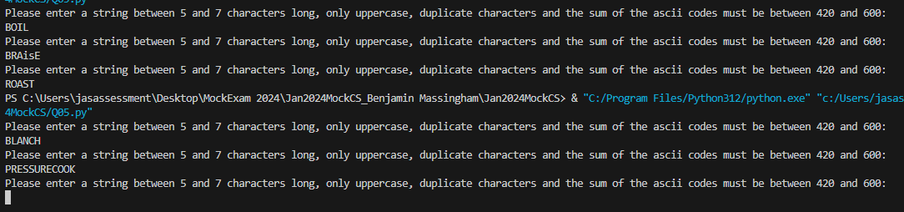
 |  |  |  |  |  | 13

Section C

Q | Answer |  | Mark  (leave blank)
6 | GRID_SIZE
7 | (a) | It spirals around 1 specific point turning a 3x3 grid into a 9 item long list, it then compares that list with the string “QQ**Q**QQ”. If it is the same, it is a match and 10 is returned
7 | (b) | No match, 0 is returned
7 | (c) | It adds all of the spaces to a list of blocked spaces which cannot be entered on
8 | (a) | Inherits is when a class object takes all of the information from its parents class like its attributes and methods but isn’t closely linked with that class so if the parent dies the child can still live on
8 | (b) | It is easier for the programmer to understand when reading through the code that the character “@” is a strictly blocked cell and not a scoring character  It means that the user cannot enter the character @ it gets blocked straight away and isn’t placed on the board without having to go through all of the validation checks that are in the cell class
8 | (c) | Override is when the child class has a method or attribute in it which has the same name as one in the parent class. This is called overriding and is used so that the child class can have its own variation of a method or attribute
9 | (a) | The method does not return any data and thus it all happens inside of the method, this is why it is encapsulated
9 | (b) | It will return the value of self.__Grid[102]
10 | (a) | Once the square 3,3 has been checked once, it gets added to the not allowed symbols list and therefore does not get checked again, this is why they are awarded 10 and not 40
10 | (b) | 3,3 5,3 1,1 5,1

Section D

Q | Answer | Mark  (leave blank)
11 | def __init__(self, *args):  if len(args) == 1:  self.__Score = 0  self.__SymbolsLeft = 0  self.__GridSize = 0  self.__Grid = []  self.__AllowedPatterns = []  self.__AllowedSymbols = []  self.__LoadPuzzle(args[0])  else:  self.__Score = 0  self.__SymbolsLeft = args[1]  self.__GridSize = args[0]  self.__Grid = []  for Count in range(1, self.__GridSize * self.__GridSize + 1):  if random.randrange(1, 101) < 90:  C = Cell()  else:  C = BlockedCell()  self.__Grid.append(C)  self.__AllowedPatterns = []  self.__AllowedSymbols = []  QPattern = Pattern("Q", "QQ**Q**QQ")  self.__AllowedPatterns.append(QPattern)  self.__AllowedSymbols.append("Q")  XPattern = Pattern("X", "X*X*X*X*X")  self.__AllowedPatterns.append(XPattern)  self.__AllowedSymbols.append("X")  TPattern = Pattern("T", "TTT**T**T")  self.__AllowedPatterns.append(TPattern)  self.__AllowedSymbols.append("T")  CPattern = Pattern("C", "CCC*CCCC*")  self.__AllowedPatterns.append(CPattern)  self.__AllowedSymbols.append("C")  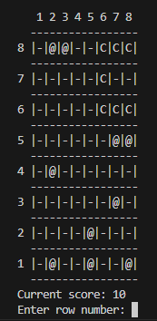
12 | def AttemptPuzzle(self):  Finished = False  while not Finished:  self.DisplayPuzzle()  print("Current score: " + str(self.__Score))  print("Symbols left: " + str(self.__SymbolsLeft))  valid = False  while not valid:  try:  TurnType = input("Enter + for adding a symbol or - for removing a symbol: ")  valid = True  except:  pass  Row = -1  Valid = False  while not Valid:  try:  Row = int(input("Enter row number: "))  Valid = True  except:  pass  Column = -1  Valid = False  while not Valid:  try:  Column = int(input("Enter column number: "))  Valid = True  except:  pass  if TurnType == "+":  Symbol = self.__GetSymbolFromUser()  self.__SymbolsLeft -= 1  CurrentCell = self.__GetCell(Row, Column)  if CurrentCell.CheckSymbolAllowed(Symbol):  CurrentCell.ChangeSymbolInCell(Symbol)  AmountToAddToScore = self.CheckforMatchWithPattern(Row, Column)  if AmountToAddToScore > 0:  self.__Score += AmountToAddToScore  if TurnType == "-":  CurrentCell = self.__GetCell(Row, Column)  if CurrentCell.IsEmpty():  print("The cell you are trying to remove is empty")  else:  if CurrentCell.CheckSymbolAllowed(CurrentCell.GetSymbol()):  CurrentCell.ChangeSymbolInCell("")  self.__SymbolsLeft += 1  else:  print('You cannot remove that symbol')  if self.__SymbolsLeft == 0:  Finished = True  print()  self.DisplayPuzzle()  print()  return self.__Score  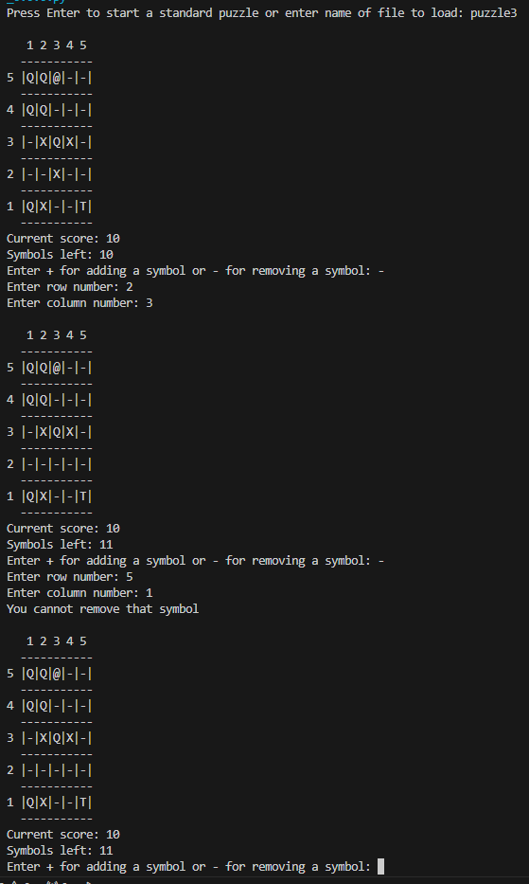
13 | class DoublePointCell(Cell):  def __init__(self):  super(DoublePointCell, self).__init__()  self._Symbol = "D"  def IsDouble(self):  return True  def __init__(self, *args):  if len(args) == 1:  self.__Score = 0  self.__SymbolsLeft = 0  self.__GridSize = 0  self.__Grid = []  self.__AllowedPatterns = []  self.__AllowedSymbols = []  self.__LoadPuzzle(args[0])  else:  self.__Score = 0  self.__SymbolsLeft = args[1]  self.__GridSize = args[0]  self.__Grid = []  self.__AmountOfDoubles = 5  for Count in range(1, self.__GridSize * self.__GridSize + 1):  if random.randrange(1, 101) < 90:  C = Cell()  else:  C = BlockedCell()  self.__Grid.append(C)  while self.__AmountOfDoubles > 0:  position = random.randrange(len(self.__Grid))  if self.__Grid[position].IsEmpty:  self.__Grid[position] = DoublePointCell()  self.__AmountOfDoubles -=1  self.__AllowedPatterns = []  self.__AllowedSymbols = []  QPattern = Pattern("Q", "QQ**Q**QQ")  self.__AllowedPatterns.append(QPattern)  self.__AllowedSymbols.append("Q")  XPattern = Pattern("X", "X*X*X*X*X")  self.__AllowedPatterns.append(XPattern)  self.__AllowedSymbols.append("X")  TPattern = Pattern("T", "TTT**T**T")  self.__AllowedPatterns.append(TPattern)  self.__AllowedSymbols.append("T")  CPattern = Pattern("C", "CCC*CCCC*")  self.__AllowedPatterns.append(CPattern)  self.__AllowedSymbols.append("C")
14

If you have made any separate screen captures, put a reference in the correct place in this Electronic Answer Document.

Ensure that your Centre Number, Candidate Name and Candidate Number are on each sheet.

Attach them to the back of this document.

NB: The AQA logo is provided for use only in the Electronic Answer Document for the 2023 A-level Computer Science Paper 1 (7517/1) examination and must not be used for any other purpose.

Copyright © 2023 AQA and its licensors. All rights reserved.

